2020 SSEO DSR Analysis – Summary of Results

# **Models**

1. Distance Model Fitting
2. Cosine Adjustment
3. Cosine Adjustment with Hazard Rate Key Function
4. Hazard Key Function with Hermite Polynomial Adjustment

# **Distance Model Fitting (Model 1)**

**Goodness of Fit**

Test statistic = 0.174312 **p-value = 0.3233**

**Statistic Summary**

Region Area CoveredArea Effort n k ER se.ER cv.ER

SSEO 1056 0.2552723 32828.05 445 33 0.01355548 0.001795482 0.1324543

Summary for ds object

Number of observations: 349

Distance range: 0 – 3.888021

**AIC: 884.4848**

Detection function:

Half-normal key function

Detection function parameters

Scale coefficient(s):

estimate se

(Intercept) **0.7574748 0.07195423**

Estimate SE CV

Average p 0.6405684 0.03243043 0.05062758

N in covered region 544.8286127 32.65810940 0.05994199

**Abundance and Density Estimate**

###Abundance Estimate#######################################################

sseo.model1$dht$individuals$N

Label Estimate se cv lcl ucl df

1 Total 2253825 324502.9 0.1439788 1687879 3009532 41.59067

###Density Estimate########################################################

sseo.model1$dht$individuals$D

# Label Estimate se cv lcl ucl df

# 1 Total **2134.304** 307.2944 **0.1439788** 1598.37 2849.936 41.59067

# **Cosine Adjustment (Model 2)**

**Goodness of Fit**

Test statistic = 0.0297284 **p-value = 0.977052**

**Statistic Summary**

Summary for distance analysis

Number of observations: 349

Distance range: 0 - 3.888021

Model: Half-normal key function with cosine adjustment terms of order 2,3

Fitting half-normal key function

Key only model: not constraining for monotonicity.

AIC= 1088.04

Fitting half-normal key function with cosine(2) adjustments

AIC= 1087.649

Fitting half-normal key function with cosine(2,3) adjustments

AIC= 1086.148

Fitting half-normal key function with cosine(2,3,4) adjustments

AIC= 1088.142

Half-normal key function with cosine(2,3) adjustments selected.

Strict monotonicity constraints were enforced.

AIC: **882.064**

Detection function parameters

Scale coefficient(s):

estimate se

(Intercept) **0.7319098 0.06927847**

Adjustment term coefficient(s):

estimate se

cos, order 2 -0.1911982 0.08144747

cos, order 3 0.1280513 0.07994090

Estimate SE CV

**Average p** 0.6745605 0.07460608 0.1105995

N in covered region 517.3739338 59.36231668 0.1147377

**Summary statistics:**

Region Area CoveredArea Effort n k ER se.ER cv.ER

1 SSEO 1056 0.2552723 32828.05 349 33 **0.01063115** 0.001432909 0.134784

**Abundance and Density Estimate**

> ###Abundance Estimate######################################################

> sseo.model2$dht$individuals$N

Label Estimate se cv lcl ucl df

1 Total 2140251 373159.4 0.1743531 1517269 3019026 85.99552

> ###Density Estimate########################################################

> sseo.model2$dht$individuals$D

Density:

Label Estimate se cv lcl ucl df

1 Total **2026.753** 353.3706 **0.1743531** 1436.808 2858.926 85.99552

# **Cosine Adjustment with Hazard Rate Key Function (Model 3)**

**Goodness of Fit**

Test statistic = 0.0762134 **p-value = 0.71404**

**Statistic Summary**

Summary for distance analysis

Number of observations: 349

Distance range: 0 - 3.888021

Mode: Hazard-rate key function with cosine adjustment term of order 2

Model: Hazard-rate key function

AIC: **880.9704**

Fitting hazard-rate key function

Key only model: not constraining for monotonicity.

AIC= 880.97

Fitting hazard-rate key function with cosine(2) adjustments

AIC= 881.951

Hazard-rate key function selected.

Detection function parameters

Scale coefficient(s):

estimate se

(Intercept) **0.9667079 0.05485278**

Shape coefficient(s):

estimate se

(Intercept) 1.543176 0.2358892

Estimate SE CV

Average p 0.7558762 0.02772782 0.03668302

N in covered region 461.7158174 20.88027264 0.04522321

Summary statistics:

Region Area CoveredArea Effort n k ER se.ER cv.ER

1 SSEO 1056 0.2552723 32828.05 349 33 0.01063115 0.001432909 0.134784

**Abundance and Density Estimate**

###Abundance Estimate########################################################

sseo.model3$dht$individuals$N

Label Estimate se cv lcl ucl df

1 Total 1910007 266802.6 0.1396867 1441112 2531468 36.8975

###Density Estimate##########################################################

sseo.model3$dht$individuals$D

Density:

Label Estimate se cv lcl ucl df

1 Total **1808.719** 252.654 **0.1396867** 1364.689 2397.223 36.8975

# **Hazard Key Function with Hermite Polynomial Adjustment (Model 4)**

**Goodness of Fit**

Test statistic = 0.0762134 p-value = 0.71404

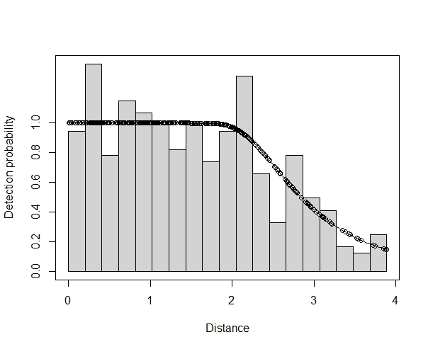

**Statistic Summary**

Summary for distance analysis

Number of observations: 349

Distance range: 0 - 3.888021

Model: Hazard-rate key function with Hermite polynomial adjustment term of

order 4

Model: Hazard-rate key function

AIC: **880.9704**

Fitting hazard-rate key function

Key only model: not constraining for monotonicity.

AIC= 880.97

Fitting hazard-rate key function with Hermite(4) adjustments

AIC= 882.304

Hazard-rate key function selected.

Detection function parameters

Scale coefficient(s):

estimate se

(Intercept) **0.9667079 0.05485278**

Shape coefficient(s):

estimate se

(Intercept) 1.543176 0.2358892

Estimate SE CV

Average p 0.7558762 0.02772782 0.03668302

N in covered region 461.7158174 20.88027264 0.04522321

**Summary statistics:**

Region Area CoveredArea Effort n k ER se.ER cv.ER

1 SSEO 1056 0.2552723 32828.05 349 33 0.01063115 0.001432909 0.134784

**Abundance and Density Estimate**

###Abundance Estimate########################################################

SSEO.model4$dht$individuals$N

Label Estimate se cv lcl ucl df

1 Total 1910007 266802.6 0.1396867 1441112 2531468 36.8975

###Density Estimate##########################################################

SSEO.model4$dht$individuals$D

# Label Estimate se cv lcl ucl df

# 1 Total **1808.719** 252.654 **0.1396867** 1364.689 2397.223 36.8975

# Comparing Models

|  |  |  |  |  |
| --- | --- | --- | --- | --- |
|  | **Model 1** | **Model 2** | **Model 3** | **Model 4** |
| **p-value** | 0.323 | 0.977 | 0.714 | 0.714 |
| **AIC** | 844.5 | 822.1 | 881.0 | 881.0 |
| **Detection function parameters, scale coefficient** |  |  |  |  |
| **Estimate** | 0.757 | 0.732 | 0.967 | 0.967 |
| **SE** | 0.072 | 0.069 | 0.055 | 0.055 |
| **Density Estimate** | 2134.000 | 2027.000 | 1808.719 | 1808.719 |
| **CV** | 0.144 | 0.174 | 0.140 | 0.140 |
| **Notes** | GFT plot - residuals not fitting line well | GFT plot - residuals fit line well | GFT plot - residuals not fitting line well | GFT plot - residuals not fitting line well |
|  | Has low cv, but higher AIC and very low -p-value | Highest p-value of all models.  Lowest AIC of all models.  But has highest CV of all models. | Has highest p-value, lower AIC, CV is higher than model 1, but lower than model 2 | Identical to model 3 (see R outputs below), but reverts back to “Hazard-rate key function selected”. |

**Model 3 OUTPUT:**

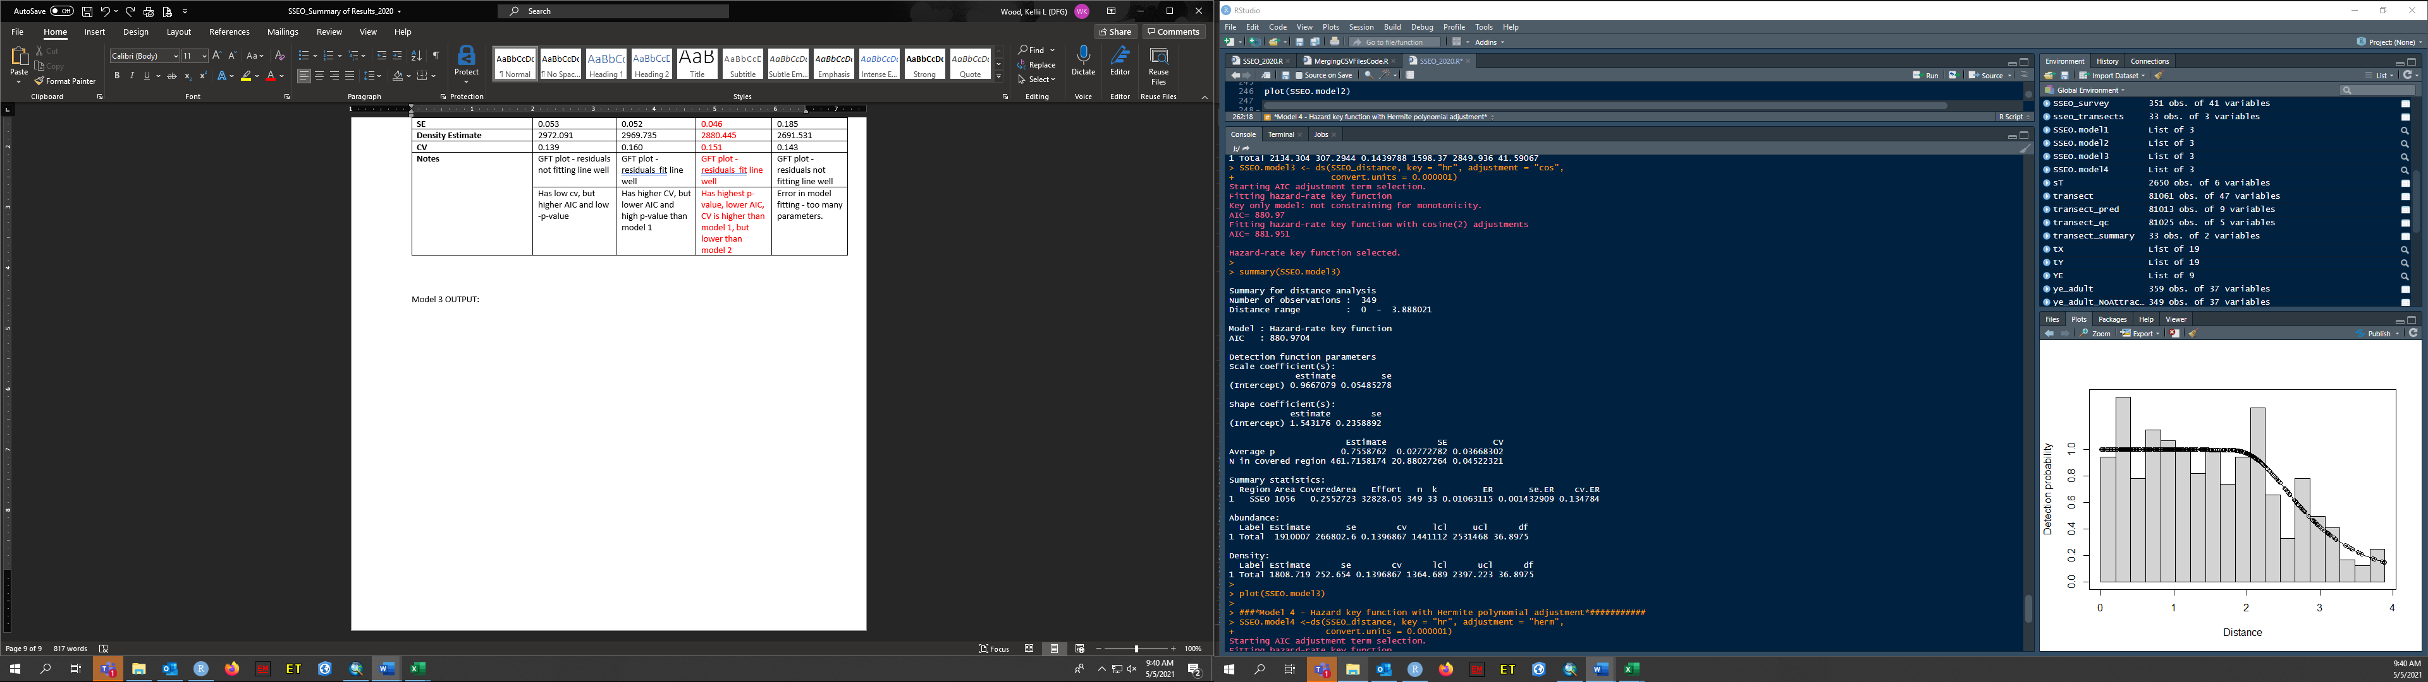

**Model 4 OUTPUT:**

